|  |  |  |
| --- | --- | --- |
| **CHUKA** |  | **UNIVERSITY** |

**SIMPLIFIED AND ADAPTIVE E-LEARNING SYSTEM**

**NIGEL AMOS**

**EDS1/52265/22**

**A Proposal Submitted to The Faculty of Science Engineering and Technology in Partial Fulfillment of The Requirement for The Award of Diploma in Computer Science**

**CHUKA UNIVERSITY**

**DECEMBER, 2023**

# **DECLARATION AND RECOMMENDATION**

## **Student Declaration**

This proposal is our original work and has not been submitted for examination to any other University.

Signature: ……………………………… Date: ………………………………………

Nigel Amos, EDS1/52265/22

## **Supervisor Declaration and Recommendation**

This proposal has been submitted, examined, passed and with our approval as the University supervisors.

Signature: ……………………………… Date: ………………………………………

Mohabe Chacha,

Computer Science Department,

Chuka University.

# **ABSTRACT**

Online learning has grown tremendously, allowing people to access education conveniently. However, many systems take a one-size-fits-all approach and do not adapt to individual learners' needs. Personalized and adaptive learning systems tailor the learning experience to each user's strengths, weaknesses, and preferences, leading to better engagement, comprehension, and retention. There is a need for an intuitive system that provides customized learning paths and continues where users left off.

Learning Simplified will allow users to create an account and log in to access courses. Courses will be individualized through adaptive algorithms that assess the user's skill level and learning style. The course content and activities will adapt accordingly. If a user logs out before completing a course, their progress will be saved. Upon logging back in, they will see a dashboard with their courses in progress and can continue from where they left off seamlessly. The system will use data analytics to refine its adaptation strategies over time.

The system will be developed using ReactJS and ExpressJS, which allow for adaptive algorithms and save states. User accounts, progress, and course data will be stored in a MySQL database. The interface will be responsive for accessibility across devices. Learning Simplified aims to provide an intuitive, adaptive online learning platform that personalizes delivery and allows users to continue progress from any device. If successful, it could greatly improve online learning and be extended to various education contexts. User-centered testing and development will drive innovations in adaptive learning technology.

Table of Contents

**DECLARATION AND RECOMMENDATION** ii

**Student Declaration** ii

**Supervisor Declaration and Recommendation** ii

**ABSTRACT** iii

**CHAPTER ONE: INTRODUCTION** 1

**1.1 Background of Study** 1

**1.2 Statement of the Problem** 1

**1.3 Aim of the Project** 1

**1.4 Specific Objectives** 2

**1.5 Justification of Study** 2

**1.6 Scope of Study** 2

**CHAPTER TWO: LITERATURE REVIEW** 3

**2.1 Introduction** 3

**2.2 The Potential of Adaptive E-Learning** 3

**2.3 Considerations for Adaptive E-Learning in the African Context** 4

**2.4 Summary** 4

**CHAPTER THREE: METHODOLOGY** 6

**3.1 Agile methodology** 6

**3.1.1 About Agile methodology** 6

**3.2 Technology and Tools for creation** 6

**3.2.1 Programming language.** 6

**3.2.2 Database** 7

**3.2.3 IDE** 8

**3.2.4 Browser to be used** 8

**3.2.5 OS** 8

CHAPTER FOUR: SYSTEM ANALYSIS AND DESIGN 9

**WORKPLAN** 13

**BUDGET** 15

**References** 16

## **CHAPTER ONE: INTRODUCTION**

## **1.1 Background of Study**

Online learning has surged in Kenya due to the COVID-19 pandemic's disruption of traditional education models. Kenya's digital learning market is projected to reach $325 million by 2026 as internet access and mobile device adoption increase, fueling demand for remote education (Research and Markets, 2021). However, high dropout and dissatisfaction plague many current e-learning platforms due to their one-size-fits-all, static course delivery models that fail to adapt to diverse learners (Nyerere, 2020).

Adaptive learning technologies tailor educational experiences to each student's unique needs and preferences in real-time by continually assessing their skill levels, knowledge gaps, and progress. Studies across Africa show adaptive systems enhance outcomes, engagement, equity, and satisfaction compared to standardized platforms (Somyürek, 2015; Oxman & Wong, 2014). Adaptivity also enables the personalization required to make online learning successful across diverse contexts like Kenya.

Yet barriers persist in implementing effective, scalable adaptive learning solutions across the continent. There is a timely need for adaptive platforms with robust progress-tracking features and intuitive interfaces tailored specifically for African learner populations. Learning Simplified aims to address this need through a personalized, device-agnostic e-learning system designed for Kenya and beyond.

## **1.2 Statement of the Problem**

Fixed one-size-fits-all online learning fails diverse students in Kenya and Africa by not adapting to individual skills, gaps, and learning styles. This leads to disengagement, poor comprehension, high dropout rates, and inequities. Targeted solutions are urgently required that dynamically personalize sequencing, content, activities, and feedback for each learner in real-time based on ongoing needs assessments.

## **1.3 Aim of the Project**

To design and develop an adaptive, personalized online learning system called Learning Simplified to improve engagement, outcomes, and equity in Kenya through tailored learning paths, omnichannel accessibility, and context-specific design.

## **1.4 Specific Objectives**

* Develop algorithms to continually assess each learner's competencies, gaps, pace and preferences to enable adaptive course delivery.
* Build customizable course templates with Kenyan pedagogical principles adaptable to each learner.
* Implement progress tracking for multi-device access and completion.
* Create an intuitive mobile-first interface optimizing user experience.
* Conduct extensive testing to refine adaptivity and enhance usability.

## **1.5 Justification of Study**

Learning Simplified has significant potential to enhance online learning effectiveness, completion rates, and equitable access across Kenya's diverse student base by leveraging proven adaptive technologies. Given the rapid e-learning expansion in Kenya, solutions that improve personalization and outcomes are critically needed.

## **1.6 Scope of Study**

This project focuses on Learning Simplified's core adaptive engine, progress-tracking, customizable course templates and intuitive interface. Initial testing will evaluate adaptivity, usability and device access using representative subject templates. The scope centers on developing the adaptive platform rather than content authoring.

# **CHAPTER TWO: LITERATURE REVIEW**

## **2.1 Introduction**

The evolution of e-learning in Africa and a rising demand for flexible, remote education (Nyerere, 2020). Despite this growth, many e-learning initiatives face a critical challenge: high dropout rates attributed to standardized course delivery models that overlook the diverse needs of learners (Somyürek, 2015). In response, adaptive learning systems have emerged as a promising solution, continuously assessing individuals to tailor learning paths aligned with each student's unique competencies and preferences (Oxman & Wong, 2014). This literature review aims to explore research on the benefits of adaptive e-learning and contextual considerations essential for effective implementation in Africa, with a focus on Kenya.

## **2.2 The Potential of Adaptive E-Learning**

Adaptive learning, utilizing data analytics and algorithms, dynamically adjusts learning experiences based on ongoing progress assessments and demonstrated skill levels (Somyürek, 2015). Oxman and Wong (2014) emphasize that personalized learning paths in adaptive systems lead to improved outcomes and higher engagement compared to standardized e-learning platforms. A study of 72 students, notably in Kenya, has been extraordinary in recent years, driven by increased internet connectivity over four months demonstrated an 8% increase in median exam scores and an 18% rise in completed exercises using an adaptive learning environment (Oxman & Wong, 2014).

Furthermore, adaptive systems support self-paced learning, accommodating individual speeds and competencies to minimize frustration (Somyürek, 2015). They enhance access and equity, providing additional support for struggling students while allowing advanced learners to pursue enrichment (Oxman & Wong, 2014). The additivity feature also enables tailored feedback, practice opportunities, and multimedia resources catering to diverse learning preferences (Somyürek, 2015). By addressing each learner's unique needs, adaptive learning holds great promise in elevating online education engagement, outcomes, and satisfaction across diverse student groups (Oxman & Wong, 2014).

## **2.3 Considerations for Adaptive E-Learning in the African Context**

Successful deployment of adaptive platforms in Africa requires careful contextualization, considering diverse landscapes (Somyürek, 2015). Factors such as infrastructure, culture, pedagogy, policy environments, and past educational experiences are pivotal (Somyürek, 2015). Designers must account for localized needs related to curriculum, language, device accessibility, instructional culture, and targeted competencies (Nyerere, 2020; Somyürek, 2015).

Challenges like unreliable electricity access and e-payment integration issues may limit adaptive technologies in many African countries (Somyürek, 2015; Nyerere, 2020). Cultural nuances influencing teaching methods, technology adoption patterns, and design preferences further complicate implementation (Somyürek, 2015). To maximize effectiveness for underserved populations, incorporation of contextual perspectives through local partnerships and testing is crucial (Somyürek, 2015). Subsequent research should analyze local implementations to refine best practices for successful adaptive e-learning initiatives.

## **2.4 Summary**

In summary, adaptive learning systems show promise for enhancing personalization, outcomes, equity, and satisfaction in e-learning across diverse African landscapes (Oxman & Wong, 2014; Somyürek, 2015). Effectiveness depends on thoughtful localization, addressing unique technological capacities, pedagogical norms, culture, past educational experiences, and policy environments (Nyerere, 2020; Somyürek, 2015). Further research and testing are crucial to develop best practices for adaptive technologies in Africa, avoiding one-size-fits-all assumptions (Somyürek, 2015).

Insights can inform the development of adaptive solutions, such as the proposed "Learning Simplified" for the educational landscape of Kenya. Ongoing research should assess localization approaches, evaluate impacts on learning outcomes and equity, analyze infrastructural barriers, and document best practices for sustainability and scalability across diverse African contexts.

# **CHAPTER THREE: METHODOLOGY**

## **3.1 Agile methodology**

The system is planned to be developed by using agile as a methodology. Agile methodology is an approach that involves breaking the project into phases emphasizing continuous collaboration and improvement.

### **3.1.1 About Agile methodology**

Agile is mostly recommended unlike other methodologies cause of it has many advantages.

Flexibility so as to allow changes to be made.

* Allows for customer satisfaction.
* Faster time to market.
* Continuous improvements.
* Collaboration approach among team fostering problem solving.
* Reduces risks through regular testing.

Due to the advantageous circumstances of the methodology the project will be well developed.

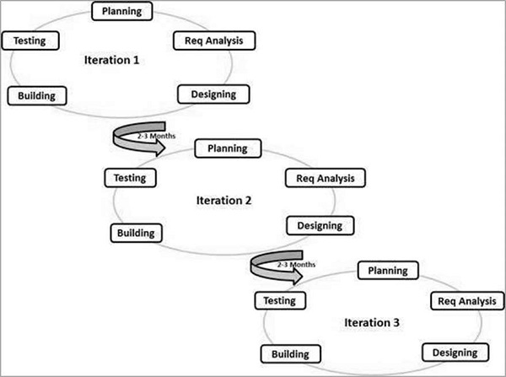

## **3.2 Technology and Tools for creation**

### **3.2.1 Programming language.**

For the project Express.js and React.js will be suitable for the development and creation of the program.

React.js is a JavaScript library for building user interfaces, particularly for building single-page applications where user interfaces need to be highly interactive and responsive. Developed and maintained by Facebook, React.js (or simply React) is open-source and has gained widespread adoption in the web development community. It has key aspects

Component-Based Architecture.

* Virtual DOM.
* JSX (JavaScript XML).
* Unidirectional Data Flow.
* Declarative Syntax.
* React Hooks.
* Reconciliation..
* One-Way Data Binding.
* React Router.
* Community and Ecosystem.

Also with the help of Express.js which is commonly known as Express, is a web application framework for Node.js. It is designed to simplify the process of building web applications and APIs by providing a minimal and flexible set of tools and features. Express.js is widely used for creating server-side applications and RESTful APIs with Node.js.

The key features are;

* Middleware.
* Routing.
* HTTP Utility Methods.
* Template Engines.
* Static File Serving.
* Error Handling.
* Middleware and Route Composition.
* Integration with Other Modules.
* RESTful API Development..
* Active Community.

Express.js will be used for backend and React.js will be used for fronted.

### **3.2.2 Database**

In terms of database MySQL is the best option. MySQL is an open-source relational database management.

Using MySQL in conjunction with Express.js (backend) and React.js (frontend) can provide several advantages in building web applications. Here are some benefits of using MySQL

* Relational Database Management System (RDBMS)
* Data Integrity and ACID Compliance
* SQL Language Standardization
* Scalability
* Community and Support
* Compatibility with ORM (Object-Relational Mapping)
* Security Features
* Transaction Support
* Reliability and Performance
* Compatibility with React.js
* Maturity and Stability

### **3.2.3 IDE**

The favorite tool to be used in this case will be Visual studio code. Visual Studio Code is a lightweight, free, and open-source code editor developed by Microsoft. It has excellent support for JavaScript, Typescript, and extensions that enhance the development experience for both Express.js and React.js.

### **3.2.4 Browser to be used**

Browsers play a crucial role in the development and testing of web applications Google Chrome and Fire fox will be used.

### **3.2.5 OS**

Windows as an OS chosen will be active during the development because it is a widely used operating system, and it is fully compatible with both Express.js and React.js development. Many developers use Windows with tools like Visual Studio Code for a seamless coding experience.

# **CHAPTER FOUR: SYSTEM ANALYSIS AND DESIGN**

## **4.1 System Analysis**

### **4.1.1 USE CASE DIAGRAM**

Use Case Diagram (Simplified and Adaptive E-Learning System): The use case diagram provides a high-level overview of the interactions between actors and use cases in the System.

* Actors: The actors in this system are Student, Instructor, and Administrator.
* Use Cases: Use cases include Browse Courses, Enroll in Course, Access Course Content, Submit Assignments, Take Quizzes/Exams, and Participate in Discussions, Generate Reports, Manage Courses, and Administrate System.
* Associations: Associations between actors and use cases indicate the interactions. For example, the Student can Browse Courses, Enroll in Course, etc.
* System Boundary: The use cases are enclosed within the system boundary, representing the scope of the System.

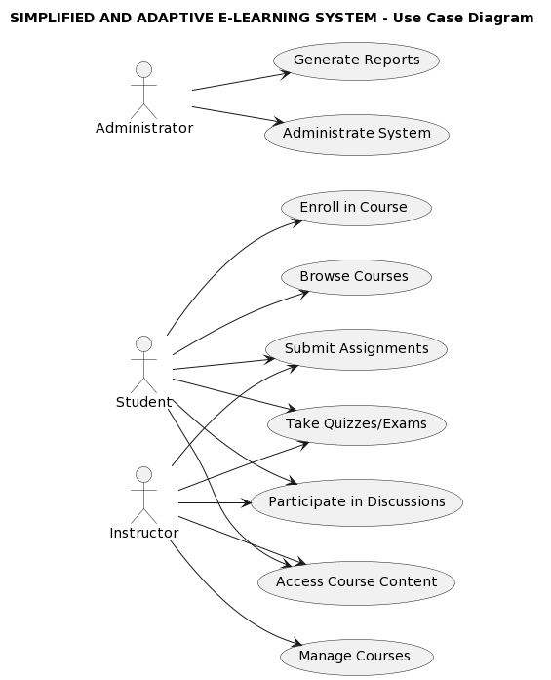

### **4.1.2 ACTIVITY DIAGRAM**

The activity diagram represents the dynamic flow of activities within the System.

* Start and End: The diagram begins with a start node and ends with a stop node, indicating the start and end of the system interaction.
* Login and Logout: Depending on whether the user is logged in or not, the system either performs a logout or initiates the login process.
* Browse Courses: The user, whether logged in or not, can browse available courses.
* Enroll in Course: If the user is logged in and selects a course, they can enroll in that course.
* Access Course Content: After enrolling, the user can access the content of the selected course.
* Submit Assignments, Take Quizzes/Exams, and Participate in Discussions: Depending on the course content, the user may submit assignments, take quizzes/exams, and participate in discussions.
* Generate Reports: If the user is an administrator, they can generate reports.

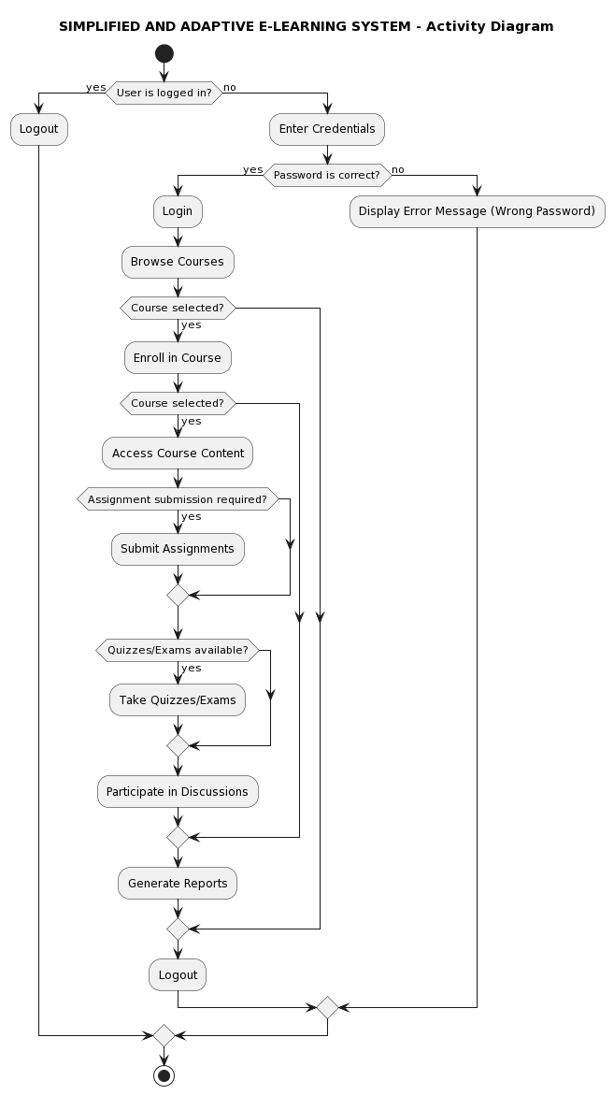

# **WORKPLAN**

The following if the breakdown of the work plan and a Gantt chart

|  |  |  |
| --- | --- | --- |
| month |  |  |
| **Month 1** | **Week 1:** **Requirements gathering** | * Review current systems data * Draft user stories |
| **Week 2. Backend development** | * Set up Express server * Build out MySQL DB Schema * Develop user authentication APIs |
| **Week 3: Frontend development** | * Implement user auth screens * Develop homepage and header * Set up React router |
| **Month 2** | **Week 4: Frontend development** | * User dashboard * Courses dashboard |
| **Week 5: Backend enhancements** | * Additional data model APIs * Server optimizations * Authentication and Authorization |
| **Week 6: Integration and Testing** | * Connect front-end and back-end * Continuous integration pipeline |
| **Week 7 Enhancements** | * Improve authentication * Notifications service * Accessibility review |
| **Week 8: Load Testing** | * Setup testing environment * Traffic simulations * Performance tuning |
| **Week 9: Final Touches** | * Comprehensive testing * Documentation updates * Pre-production deployment |
| **Week 10: Presentation** | * Demo system to stakeholders * Gather feedback * Prioritize future work |

Table 1

# **BUDGET**

|  |  |  |  |  |
| --- | --- | --- | --- | --- |
| Types of costs | Tool name | Quantity | Unit price (in KSH) | Total price (in KSH) |
| Hardware costs | Computer | 1 | 50000 | 50000 |
| Printing and binding | 5(copies) | 100 | 500 |
| Hard disk | 1 * 500GB | 3000 | 3000 |
| RAM | 2 * 8GB | 4000 | 8000 |
| Software cost | Microsoft office 2019 | 1 | Free | Free |
| Microsoft Visual studio code | 1 | Free | Free |
| Windows 10 OS | 1 | Free | Free |
| Ubuntu | 1 | Free | Free |
| Other Costs | Internet bundles | 30gb monthly | 1000 | 4000 |
|  |  |  |  |  |
| Total cost |  |  |  |  |

# **References**

Nyerere, J. (2020). The Growth of eLearning in Kenya. African Journal of Online and Distance Education, 3(1).

Oxman, S., & Wong, W. (2014). White Paper: Adaptive Learning Systems. Integrated Education Solutions.

Research and Markets (2021). Kenya Digital Learning Market 2021-2027.

Somyürek, S. (2015). The new trends in adaptive educational hypermedia systems. International Review of Research in Open and Distributed Learning, 16(1), 221-241.